Practice Problems:

1. Suppose we have the following histogram of some i.i.d. samples
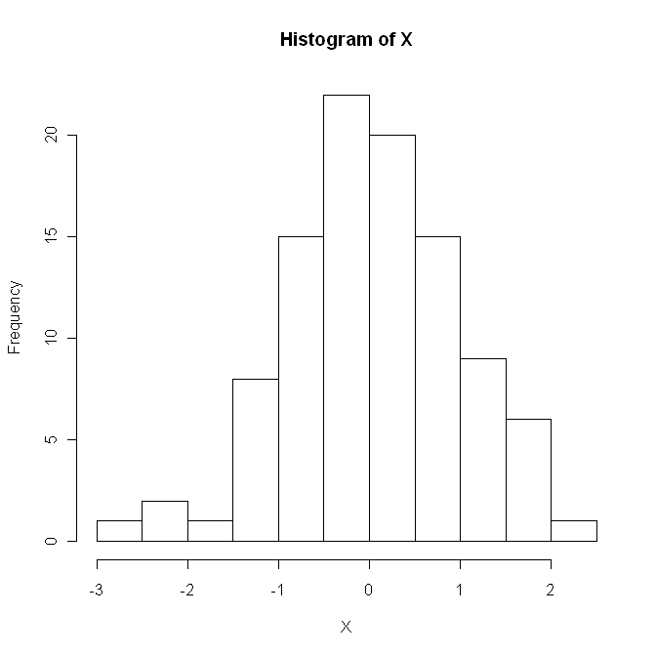
- Which of the following distributions would most likely be the distribution of the samples? Normal; Exponential; Uniform; Pareto.
- What is a boxplot? What would be the boxplot of the above samples look like?

2. Suppose we have i.i.d. samples from shifted exponential distribution, i.e. the density function is given by $f(x)=e^{−(x−δ)}$ for $x>δ$; and 0 otherwise.
- Use the first and second order moments in the method of moments to estimate $δ$.
- Find the MLE of $δ$

3. Suppose we have i.i.d. samples $X_{1},X_{2},⋯,X_{n}$ from $N(μ,σ^{2})$ distribution.
(1) Assume $σ^{2}$ is known, find a level 95% lower confidence bound for $μ$.
(2) Assume $σ^{2}$ is unknown, find a level 95% upper confidence bound for $μ$.
(3) Suppose we want to test $H_{0}:μ=0$ against $H_{1}:μ<0$ using $T=\sum{X_{i}}$ as the test statistic. For what values of $T$ should we reject the null hypothesis?
(4) Find the critical region of the level 0.05 test of the above testing problem.

