Practice Problems:

1. Suppose we have the following histogram of some i.i.d. samples
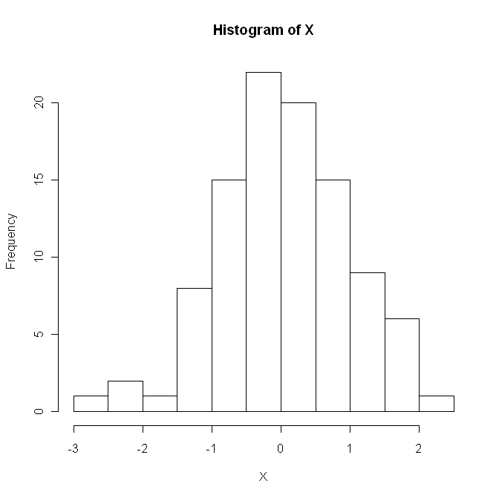
- Which of the following distributions would most likely be the distribution of the samples? Normal; Exponential; Uniform; Pareto.
- What is a boxplot? What would be the boxplot of the above samples look like?

Solution: (a) Normal. (b) The boxplot:

2. Suppose we have i.i.d. samples from shifted exponential distribution, i.e. the density function is given by for ; and 0 otherwise.
- Use the first and second order moments in the method of moments to estimate .
- Find the MLE of

Solution:
(1) Since the expectation of shifted exponential distribution is , so if we use the first order moment, the estimator will be .
Since the second order moment is , so if we use the second order moment, the estimator will be
(2) The MLE is

3. Suppose we have i.i.d. samples from distribution.
(1) Assume is known, find a level 95% lower confidence bound for .
(2) Assume is unknown, find a level 95% upper confidence bound for .
(3) Suppose we want to test against using as the test statistic. For what values of should we reject the null hypothesis?
(4) Find the critical region of the level 0.05 test of the above testing problem.

Solution:
(1) Consider , we know that , so a confidence interval can be constructed based on . The level 95% Lower CB is .
(2) Consider , where . We know that . So the level 95% upper CB is , where is the 0.95 quantile of the distribution with degrees of freedom.

- When is small enough, we should reject the null hypothesis.
- The critical region is .

